**Agreement of needs:**

How competitive would you like the game to be? Not too competitive not to many levels, gets harder as the game goes on

The game will evolve around the aspect of skill

The game will need to be light hearted and be PG rated

A high score menu would be nice to have

**Social, Ethical and Legal issues:**

Issue 1 – People with difficult understanding or disabilities; people who have difficulty in understanding what the game is about, can access the help menu which will show them how to game is played

Issue 2 – Swear words will need to be removed from high scores list so people cant use them

Issue 3

**Story board:**

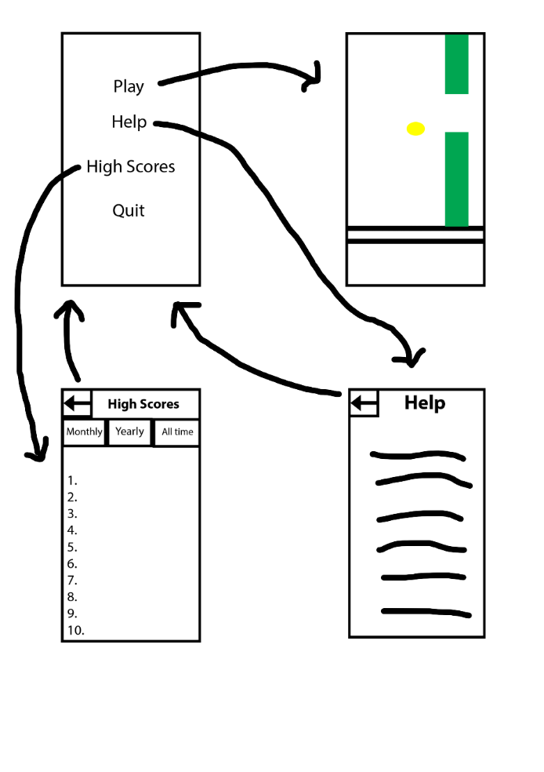

**Licence agreement:**

Copyright <2019> <ZYON SHEPHERD>

Permission is hereby granted, free of charge, to any person obtaining a copy of this software and associated documentation files (the "Software"), to deal in the Software without restriction, including without limitation the rights to use, copy, modify, merge, publish, distribute, sublicense, and/or sell copies of the Software, and to permit persons to whom the Software is furnished to do so, subject to the following conditions:

The above copyright notice and this permission notice shall be included in all copies or substantial portions of the Software.

THE SOFTWARE IS PROVIDED "AS IS", WITHOUT WARRANTY OF ANY KIND, EXPRESS OR IMPLIED, INCLUDING BUT NOT LIMITED TO THE WARRANTIES OF MERCHANTABILITY, FITNESS FOR A PARTICULAR PURPOSE AND NONINFRINGEMENT. IN NO EVENT SHALL THE AUTHORS OR COPYRIGHT HOLDERS BE LIABLE FOR ANY CLAIM, DAMAGES OR OTHER LIABILITY, WHETHER IN AN ACTION OF CONTRACT, TORT OR OTHERWISE, ARISING FROM, OUT OF OR IN CONNECTION WITH THE SOFTWARE OR THE USE OR OTHER DEALINGS IN THE SOFTWARE.